Experiment No: 3 Date: 06/03/23

Co3: Perform system Administration Task

Procedure:

Pwd : Print Working Directory.

$ pwd

Output



Ls : To listing files and directories and view the contents

$ ls

Output

$ls -R

Output

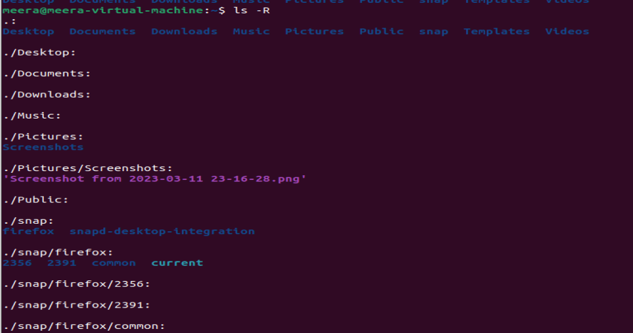

$ls -L

Output



$ ls -al

Output



$ ls -t

Output



$ ls -r



history: To review the command that have been previously executed the second period of

time.

$ history

Output

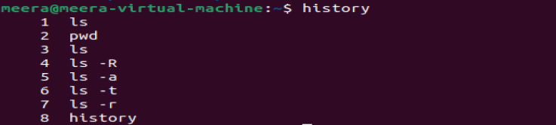

Man ls : We can learn and understand different command . write from the shell using man command.

$man ls

Output

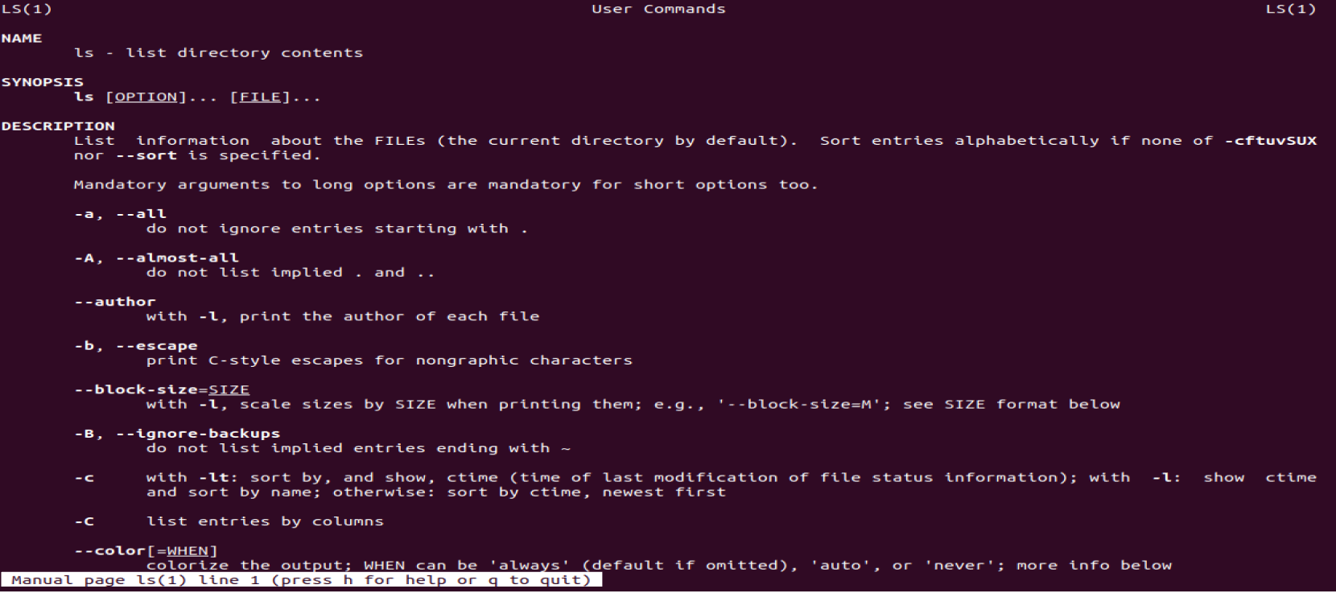

Mkdir: To create a new Directory

$ mkdir

$ ls

Output



Rmdir: To remove an Empty Directory

$ rmdir

$ ls

Output



Touch: To create a new file in Directory

$ touch file

$ ls

Output



Cat: This cat (catenated-non catenated) command is used to display the content of the specified file.

cat >f1: To create file.

$ cat>f1

Output

$ cat f1

Output

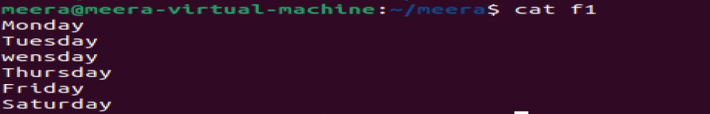

$ cat -n f1

Output

$ cat -b f1

Output

Cat >>f1: To Append text to the existing file.

$ cat >>f1

$ cat f1

Output

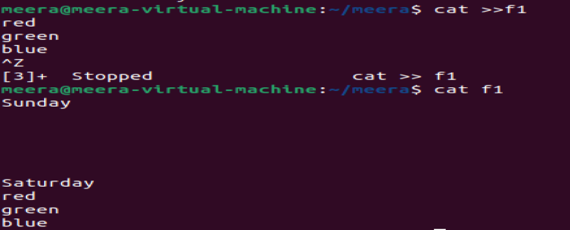

Cat f1 | tr a-z A-Z >res: To Convert text into Uppercase.

$ cat f1 | tr a-z A-Z >res

$ cat res

Output

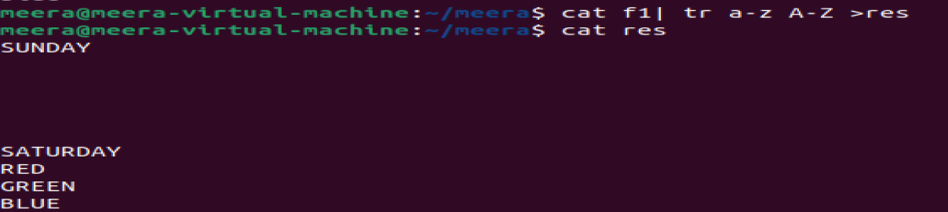

Cat f1 | tr A-Z a-z >res: To Convert text into Lowercase

$ cat f1 | tr A-Z a-z >res

$ cat res

Output

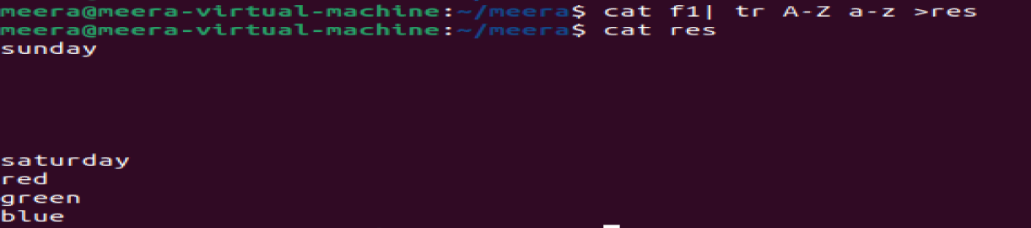

Result: The program implemented Successfully and Co3 is Obtained.